Renewable energy potential assessment

General discussion on renewable energy application
- We are interested in:
☐ reducing our company expenses in the annual energy bill
☐ having an image of a sustainable/green Finnish port
☐ becoming more self-sufficient from an energy point of view
☐ meeting EU energy targets and following EU Green Deal
☐ own reason: Click or tap here to enter text.

- We think that from a resource perspective we can apply:
☐ solar energy because the port has: Click or tap here to enter text.
☐ wind energy because the port has: Click or tap here to enter text.
☐ own solution: Click or tap here to enter text.
because the port has: Click or tap here to enter text.

- We have already used EVISA tools:
☐ pre-survey: to understand the energy status quo of the port
☐ energy mapping: to collect all port energy information in one place

A basic estimate of renewable energy potential
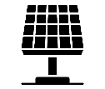Solar Energy

Case name: Click or tap here to enter text.

- Internal conditions:

1.1 Where are you going to install solar panels? Type of the space:

☐ Rooftop  ☐ External wall | ☐ Land area  ☐ Combined: Click or tap here to enter text.

1.2 How many sub-areas are you going to use for solar panel installations in the area?
E.g.: how many buildings are you going to use for solar panels?
☐ 1  ☐ 2  ☐ 3 | ☐ 4  ☐ 5  ☐ Own option:  Click or tap here to enter text.

1.3 Add here a screenshot from Google Maps of the port territory with areas you are going to use for solar panel installations:

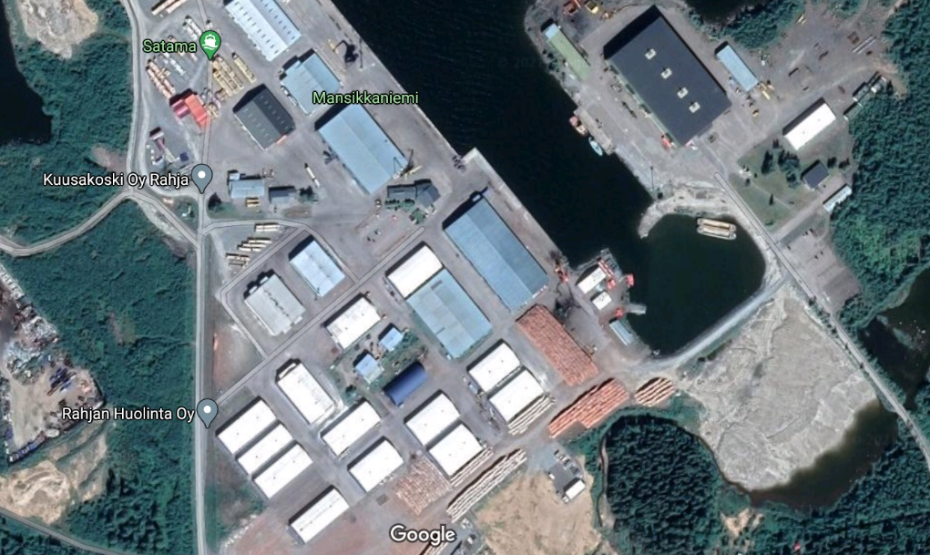

Then highlight it using the following MS Word tool: Insert -> Shapes -> Rectangle. Place a red rectangle with black borders on the area, as shown in the example above.

  - What is the total available space in the area? A = L x W = ENTER NUMBER m²
E.g.: estimate approximately the area you are going to use for solar panels. You can do it in two ways. One is when you already know the length (L, m) and width (W, m) of the rectangular area. Then you just need to multiply one by the other and you will have the surface area of the chosen rectangular, m²: A = L x W. If you do not know the length and width, you can do simple measurements in Google Maps with the “Measure distance” tool. Place your mouse cursor at the starting point of the area. Click the right mouse button: choose “measure distance” – you have your starting point ready. Then click the left mouse button to the endpoint. This way you can measure the length. Click the right mouse button and choose “Clear measurement”. After that, you can measure width with the same approach as for the length. Then calculate the surface area using the A = L x W formula. The second method works well with rectangular areas: rooftops or land surfaces.

NOTE: This value will change during the feasibility assessment of solar panel installation- after using the payback calculator.

  - What is the orientation (azimuth) of the space:
E.g.: In which direction does the selected wall or roof side look? Mind that it is not the same as in compass. In the northern hemisphere, we aim at placing solar panels southward to make them the most efficient.

- 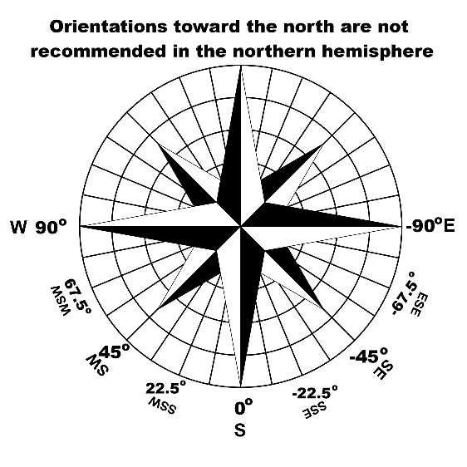 | AZIMUTH OF THE SPACE:  ☐ E, -90º  ☐ SE, -45º  ☐ S, 0º  ☐ SW, 45º  ☐ W, 90º  - ☐ another angle: Click or tap here to enter text.

1.6 What is the inclination (slope) of the space?
E.g.: horizontal roof = 0º, inclined roof = 20º, vertical wall = 90º

- 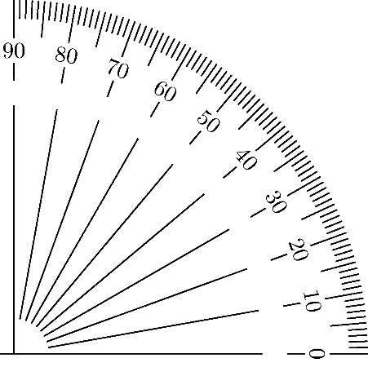 | SLOPE OF THE AREA:  ☐ 0º  ☐ 10º  ☐ 20º  ☐ 30º  ☐ 40º  ☐ 50º  ☐ 60º  ☐ 70º  ☐ 80º  ☐ 90º

1.7 Is there any shading of the space? E.g.: are there any taller buildings or trees which can block solar panels?
☐ No shading | ☐ The installation(s) may be shaded by:  Click or tap here to enter text.  E.g.: installation 1 has a taller building near it, which will block the sun for some hours.

1.8 When was the previous renovation of the roof(s) of the building(s)? Or when is the next renovation coming? Click or tap here to enter text. (DD.MM.YYYY)
E.g.: this is important to consider if solar panels are to be installed on the rooftop. Please write down either one (previous or planned renovation) or both.

1.9 What is the roof material? (if you are installing on the roof) Click or tap here to enter text. E.g.: bitumen, steel, wood or other

1.10 What is the roof carrying capacity, as stated in construction documents? ENTER NUMBER kg/m²

1.11 Will there be a person responsible in your company to clean solar panels in winter? Or will you hire a person from a cleaning company? Click or tap here to enter text.

1.12 In case there is an opportunity to collaborate with an energy-providing company: are you ready to provide an area in the port?
This means that the energy company is interested to install solar panels in the port area.
☐ Yes | ☐ No  ☐ Other: Click or tap here to enter text.

2. External conditions:

At this step, you will see what potential to produce solar energy your space has in your geographical location.

2.1 Go to https://ec.europa.eu/jrc/en/pvgis ☐ Done

2.2 Choose PV Performance Tool ☐ Done

2.3 Enter your city name in the field “Address” and click “Go!” ☐ Done

2.4 Fill in the following sections of “Performance of grid-connected PV”:

Solar radiation database: PVGIS-ERA5 (leave it unchanged) ☐ Done
PV technology: crystalline silicon (leave it unchanged) ☐ Done
Installed peak PV, power [kWp]: ENTER NUMBER ☐ Done
This is calculated with the formula: ☐ Done

$$P_{pk}=\frac{A∙{IR}_{FIN}}{1,7}$$ |  |  |  |  |  |  | , | where we have such parameters |  | and their values
 |  |  |  |  |  |  |  | Ppk - | peak power | Wp
 |  |  |  |  |  |  |  | A - | surface area of solar panel  (from Section 1.4) | m2
 |  |  |  |  |  |  |  | 1,7 - | auxiliary coefficient
 |  |  |  |  |  |  |  | IR_{FIN} - | solar irradiance in Finland | 250 W/m2

$$P_{pk}=\frac{A∙{IR}_{FIN}}{1,7}=\frac{ENTER NUMBER∙250}{1,7}= RESULT Wp=RESULT kWp$$

System loss [%]: 14 (leave it unchanged) ☐ Done
Mounting position: free-standing (leave it unchanged) ☐ Done
Slope: ENTER NUMBER (from Section 1.6) ☐ Done
Azimuth: ENTER NUMBER (from Section 1.5) ☐ Done
E.g.: in the example figure, Ppk=495 kWp, slope of 10º, and azimuth 45º.

2.5 Click “Visualize results”: You will see results first about PV output for each month of the year, plus more data on the left, as in the example figure.

When you click “Radiation” in the top right, you will see just solar data, as presented below in the example:

Note: Put the result from “yearly in-plane irradiation” into cell F28 of the calculator.
Please also put the result from the graph “monthly in-plane irradiation for fixed angle” values into 12 cells: D117 - D128.

2.6 Potential of the space for yearly PV energy production: ENTER NUMBER kWh
E.g.: in our case, it is 379926,69 kWh

2.7 The share of your current annual electricity consumption: ENTER NUMBER %
This is calculated in the following way:

$$\frac{PV energy production}{annual electricity consumption}×100$$

E.g.: if your port's annual electricity consumption is 1 000 000 kWh, then 38% would be the share. We calculated it $\frac{379926,69 }{1 000 000} ×100=38\%$.

Now go to the calculator.

Please do updates about the following numbers:

2.8 Available and feasible area for solar panel installation: A* = ENTER NUMBER m²
It should be based on the best/most feasible scenario for the port.
2.9 Installed peak PV power [kWp]: $P_{pk}=ENTER NUMBER kWp$
This value comes from calculator cell F25
2.10 “Visualize results” again using newly installed peak PV power in https://ec.europa.eu/jrc/en/pvgis. Insert image here with “monthly energy output from fixed-angle PV system”:

2.11 New yearly PV energy production: ENTER NUMBER kWh

2.12 Take new values in “monthly energy output from fix-angle PV system” and put them in cells: G117 - G128.

2.13 Insert here the graph “consumption vs production”:

2.14 Payback time, years: Click or tap here to enter text.

Wind energy

Case name: Click or tap here to enter text.

1 INTERNAL CONDITIONS
1.1 Where are you going to install wind turbines? Type of the space:
☐ Offshore  ☐ Onshore | Describe more here: Click or tap here to enter text.

1.2 How many wind turbines are you going to install?
☐ 1  ☐ 2  ☐ 3 | ☐ 4  ☐ 5  ☐ Own option:  Click or tap here to enter text.

1.3 Is it a collaboration with an energy-providing company, or you are realizing this renewable energy project alone?
☐ Yes, it is collaboration | ☐ No, it is our own initiative  ☐ Describe more details here:  Click or tap here to enter text.

1.4 What is the total space you are going to occupy (approximately)? Click or tap here to enter text. m²

1.5 Can you describe the parameters of the wind turbine(s) you are going to use?
☐ Height: Click or tap here to enter text.m  ☐ Rotor diameter: Click or tap here to enter text.m  ☐ Power generation: Click or tap here to enter text. kW | ☐ Additional field (if you know more parameters or if turbines are different types):  Click or tap here to enter text.

1.6 The general rule-of-thumb for wind farm spacing is that turbines are about 7 rotor diameters away from each other. Do you think the area you are providing would be enough for it? Click or tap here to enter text.

1.7 Do you know if there are any Natura 2000 areas near you or bird migration routes? Please write your answer here: Click or tap here to enter text.

1.8 Do you have industrial noise present in your area? Click or tap here to enter text.
E.g.: near Port of Tornio there is a steel factory, which constantly produces background noise. This is a favourable factor for installing wind turbines since they will not produce more noise than is already there.

2 EXTERNAL CONDITIONS

At this step, you are going to understand what potential wind energy has in your particular geographical location. Below there is a method to calculate what one turbine of your choice is going to produce in your place. Please calculate it for all considered turbines separately and then sum it up.

2.1 Go to: https://globalwindatlas.info/ ☐ Done

2.2 Find a search icon, enter your town name here and choose your location from the list with presented options: ☐ Done

2.3 After that when you located yourself on the map, find and press this sign “<” on the map to turn on the wind speed legend: ☐ Done

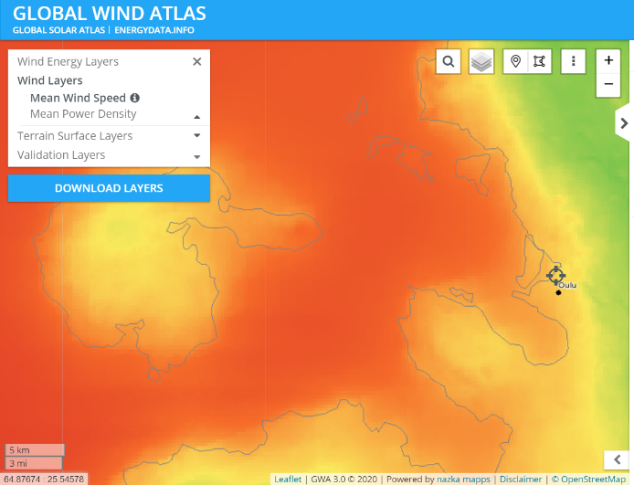 →

When you move your mouse cursor on the map, from orange to green and blue parts of it – the white triangle on the legend also moves up and down telling you the exact value in each particular point. Now you can understand what annual average speed wind has in areas next to your place. But this is not actually what we need in our further considerations. Follow the next step below.

2.4 Select in the top left corner the parameter “Mean Power Density” to update the map and have a different scale of W/m²: ☐ Done
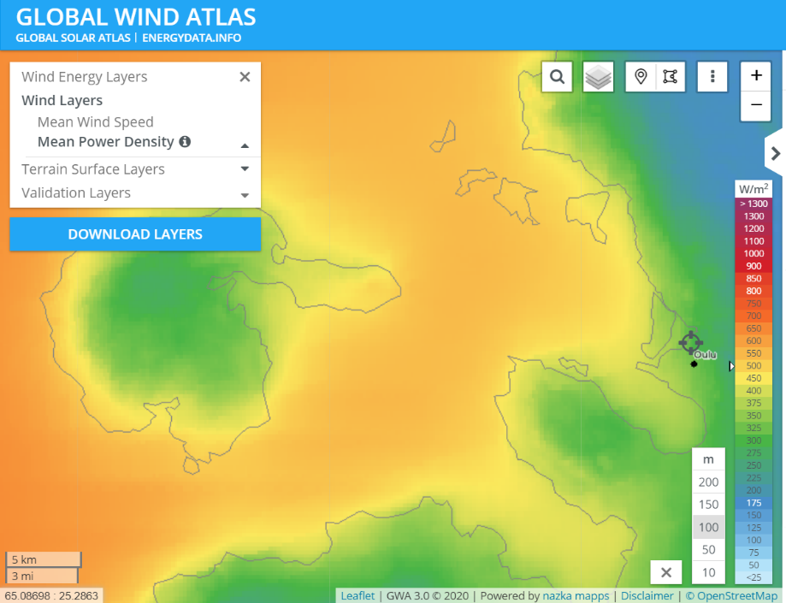

Mind that if you know the height of the turbine, you need to specify it in the field near the legend: between 10, 50, 100, 150 and 200 m. E.g.: the current picture above shows the mean power density of wind for the height of 100 m above the ground.

2.5 Find an approximate place on the map, where you would install your wind turbines. Write here a value of power density, P_{D}: ENTER NUMBER W/m² ☐ Done

If you want you can make it using “pointer”, as presented below. When you mark it on the map, you immediately get the number on the right for mean power density and mean wind speed. In our case, it is 538 W/m² and 8.07 m/s (note again: this is for winds at 100 m height)

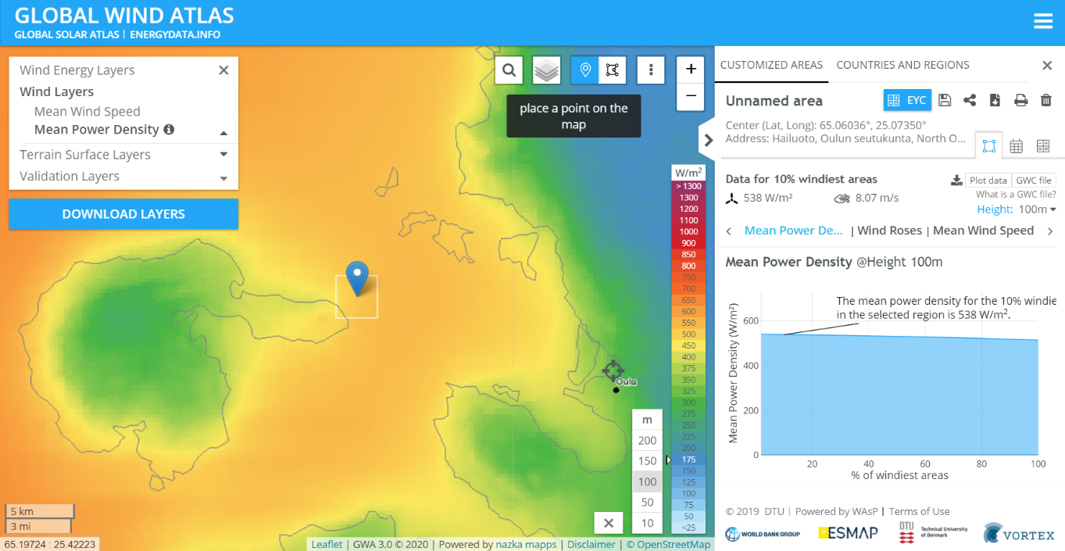

2.6 At this step, we come back again to wind turbine parameters and think of the size of our wind turbine propeller. Is it 10 m, is it 100 m? Please write its diameter D here: ENTER NUMBER m ☐ Done
E.g.: in our case, it is 128 m or D = 128 m.

2.7 Potential for wind energy generation N in your place is then found in the following way: ENTER NUMBER m²

$$N=P_{D}×S$$

where

$P_{D}$ - power density, W/m² (from Section 2.5) Click or tap here to enter text. W/m²

$S$ – surface area of the circle your propeller makes (m²).

$S$ is calculated:

$S=π×\frac{D^{2}}{4}$ , $S=3,14×\frac{{ENTER NUMBER}^{2}}{4}=$

where $D$ – diameter of the propeller, $π$ = 3.14
E.g.: in our case, we have $S=3,14×\frac{{128}^{2}}{4}=12 860$ m²

then wind energy generation $$N=P_{D}×S= × =$$

E.g.: in our case, we have N = 538 x 12 860 = 6 918 680 W = 6 919,68 kW ≈ 6 920 kWh

Write here your number for wind energy generation potential from the selected wind turbine. You can compare it with what it says (power generation) in the wind turbine description in Section 1.5. Is the calculated number the same, as was there? ENTER NUMBER kWh

E.g.: in our case, the calculated number is 6 920 kW, whereas the wind turbine manual states that is a 7580 kW turbine. This means that our turbine would not work at its full potential, based on the mean wind speed or mean power density. But it is enough for the particular environmental conditions and availability of wind in the area.

2.8 In case you have several turbines, please write here the total potential power generation: ENTER NUMBER kWh
E.g.: in our case, we use five turbines. N = 5 x 6920 = 34 600 kWh.

2.9 The share of your current annual electricity consumption: ENTER NUMBER %
This is calculated in the following way:

$$\frac{wind energy production}{annual electricity consumption}×100$$

E.g.: if your port's annual electricity consumption is 3 235 747 kWh, then 1% would be the share. We calculated it $\frac{34 600}{3 235 747}×100=1\%$

The feasibility study is not included because usually wind energy projects are conducted in collaboration with energy companies, including establishing long-term contracts and organizing environmental assessments of the area in question to receive an environmental permit for wind turbine construction. Such projects are especially common together with large industrial players, which have intensive energy consumption processes.

