Applicable measures
Action priority matrix

Guidelines: Use the matrix to select measures for your strategic energy management plan. The measures are selected based on existing gaps. The list of all measures is given below by category. A description of each measure is provided in the guidance for strategic energy management plan development.

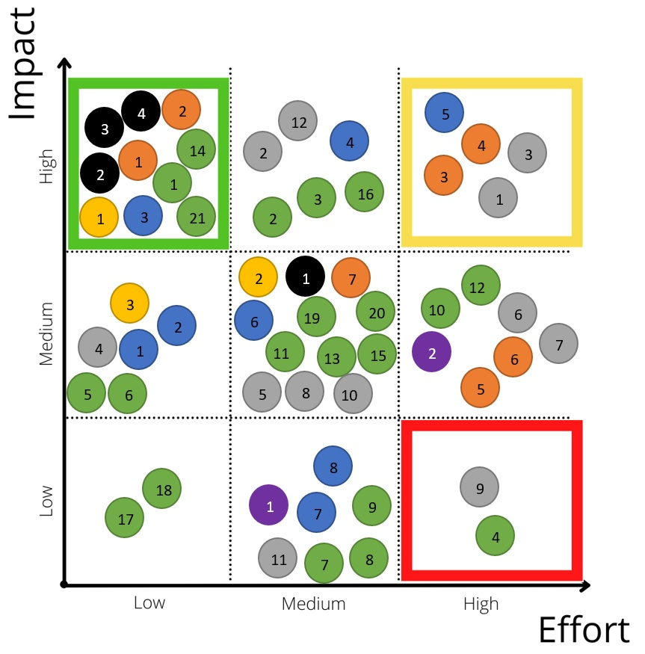

 | METERS |  | ALTERNATIVE FUELS
 | HEATING |  | RENEWABLES
 | LIGHTING |  | EFFICIENCY
 | BUILDINGS

- “METERS”:  ☐ ❶ ship environmental monitoring system  ☐ ❷ additional meters by port area and building  ☐ ❸ meters by port consumption: heating (electric and other) / water (hot and cold) / lighting / electric ventilation / fuel (benzine, diesel, gas)  ☐ ❹ installation of an online metering system | - “HEATING”:  ☐ ❶ district heating/cooling  ☐ ❷ seawater source heat pumps
- “LIGHTING”:  ☐ ❶ LED lighting  ☐ ❷ adaptive lighting system  ☐ ❸ LED floodlights and walkway lights | - “BUILDINGS”:  ☐ ❶ painting walls white/add windows  ☐ ❷ install air curtain  ☐ ❸ optimization of HVAC system  ☐ ❹ insulation  ☐ ❺ nearly zero energy building  ☐ ❻ demand-controlled ventilation system  ☐ ❼ adjusting air temperature  ☐ ❽ green roof
- “ALTERNATIVE FUELS”:  ☐ ❶ onshore power supply (OPS)  ☐ ❷ LNG PowerPac  ☐ ❸ mobile LNG barge  ☐ ❹ LNG bunkering: truck to ship  ☐ ❺ LNG bunkering: shore to ship  ☐ ❻ LNG bunkering: ship to ship  ☐ ❼ LNG bunkering: local liquefaction plant  ☐ ❽ alternative fuels  ☐ ❾ automated mooring systems  ☐ ❿ hybrid power train  ☐ ⓫ hybrid power train (plug-in hybrid)  ☐ ⓬ electrification of power train | - “RENEWABLES”:  ☐ ❶ obtain “green” energy  ☐ ❷ solar photovoltaics (PV)  ☐ ❸ wind power  ☐ ❹ hydropower  ☐ ❺ biogas  ☐ ❻ geothermal  ☐ ❼ microturbine
- “EFFICIENCY”:  ☐ ❶ energy / emission target  ☐ ❷ energy management system  ☐ ❸ energy audits  ☐ ❹ smart grid applications  ☐ ❺ employee suggestion system  ☐ ❻ employee environment training  ☐ ❼ employee bus shuttle services  ☐ ❽ provision of bikes for commuting  ☐ ❾ bundling of power  ☐ ❿ cross-company use of waste heat  ☐ ⓫ heavy duty vehicle (HDV) emission control zone  ☐ ⓬ alternative HDV cooling: DTRU | ☐ ⓭ alternative HDV cooling: grid feed  ☐ ⓮ green port fees  ☐ ⓯ slow steaming  ☐ ⓰ electrification of power train  ☐ ⓱ energy-saving tires  ☐ ⓲ tire pressure control  ☐ ⓳ regenerative drives  ☐ ⓴ emission control technologies  ☐ 21 eco-driving lessons
- “METERS”:
☐ ❶ ship environmental monitoring system
☐ ❷ additional meters by port area and building
☐ ❸ meters by port consumption: heating (electric and other) / water (hot and cold) / lighting / electric ventilation / fuel (benzine, diesel, gas)
☐ ❹ installation of an online metering system

- “HEATING”:
☐ ❶ district heating/cooling
☐ ❷ seawater source heat pumps

- “LIGHTING”:
☐ ❶ LED lighting
☐ ❷ adaptive lighting system
☐ ❸ LED floodlights and walkway lights

- “BUILDINGS”:
☐ ❶ painting walls white / add windows and skylights
☐ ❷ install air curtain
☐ ❸ optimization of HVAC system
☐ ❹ insulation
☐ ❺ nearly zero energy building
☐ ❻ demand-controlled ventilation (DCV) system
☐ ❼ adjusting air temperature
☐ ❽ green roof

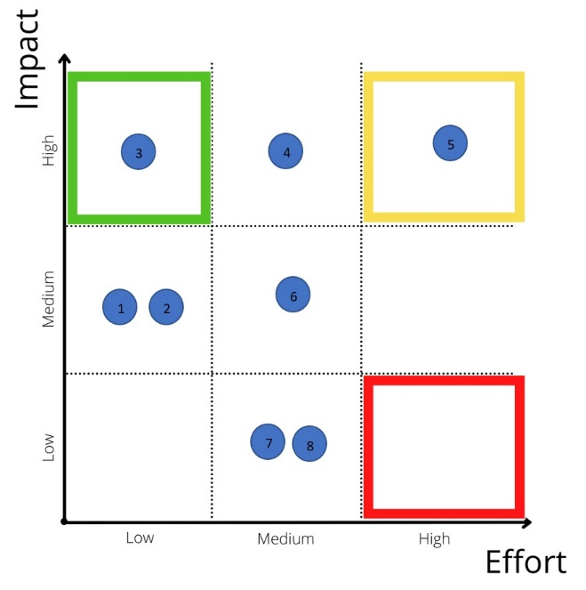
- “ALTERNATIVE FUELS”:
☐ ❶ onshore power supply (OPS)
☐ ❷ LNG PowerPac
☐ ❸ mobile LNG barge
☐ ❹ LNG bunkering: truck to ship (TTS)
☐ ❺ LNG bunkering: shore to ship
☐ ❻ LNG bunkering: ship to ship (STS)
☐ ❼ LNG bunkering: local liquefaction plant
☐ ❽ alternative fuels
☐ ❾ automated mooring systems
☐ ❿ hybrid power train
☐ ⓫ hybrid power train (plug-in hybrid)
☐ ⓬ electrification of power train (battery or fuel cell)

“RENEWABLES”:
☐ ❶ obtain “green” energy
☐ ❷ solar photovoltaics (PV)
☐ ❸ wind power
☐ ❹ hydropower
☐ ❺ biogas
☐ ❻ geothermal
☐ ❼ microturbine

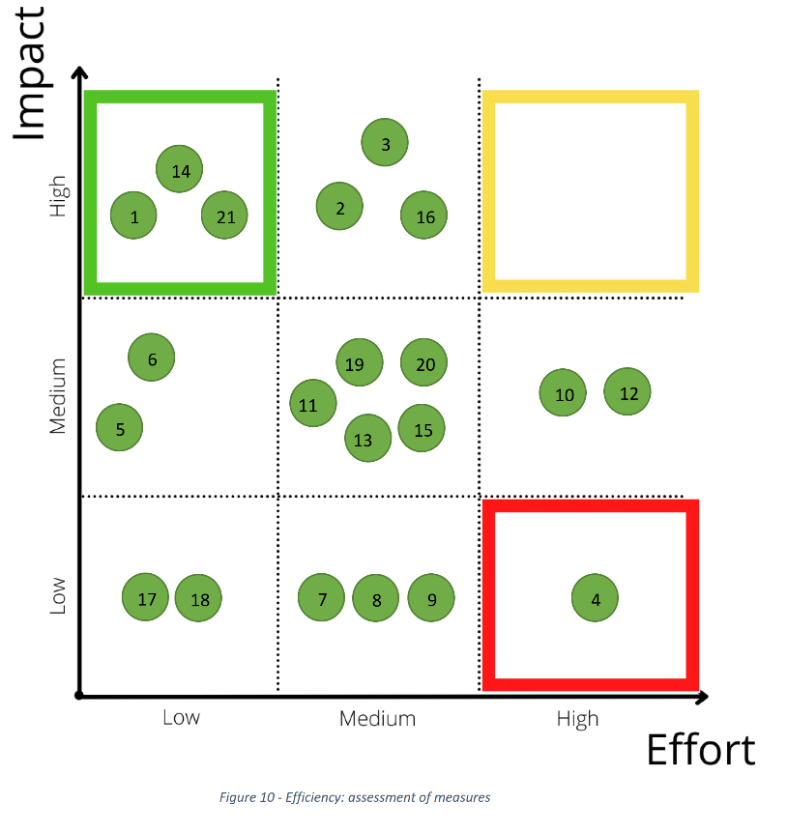
- “EFFICIENCY”:  ☐ ❶ energy / emission target  ☐ ❷ energy management system (EMS)  ☐ ❸ energy audits  ☐ ❹ smart grid applications  ☐ ❺ employee suggestion system  ☐ ❻ employee environment training  ☐ ❼ employee bus shuttle services  ☐ ❽ provision of bikes for commuting  ☐ ❾ bundling of power  ☐ ❿ cross-company use of waste heat  ☐ ⓫ heavy duty vehicle (HDV) emission control zone  ☐ ⓬ alternative HDV cooling: DTRU | ☐ ⓭ alternative HDV cooling: grid feed  ☐ ⓮ green port fees  ☐ ⓯ slow steaming  ☐ ⓰ electrification of power train  ☐ ⓱ energy-saving tires  ☐ ⓲ tire pressure control  ☐ ⓳ regenerative drives  ☐ ⓴ emission control technologies (ECTs)  ☐ 21 eco-driving lessons

